**Funnel Analysis Capstone Project Report**

**Table of Contents**

1. Executive Summary
2. Order Trend Analysis
3. Conclusion
4. Recommendations
5. **Executive Summary**

This executive summary provides an overview of the key findings and insights from the Funnel Analysis Report for Swiggy's order trends, traffic changes, and conversion fluctuations. The analysis was conducted to understand and address fluctuations in order volumes, changes in website/app traffic, and variations in conversion rates, with the goal of optimizing the platform's performance and user experience.

1. **Order Trend Analysis**

* **January**

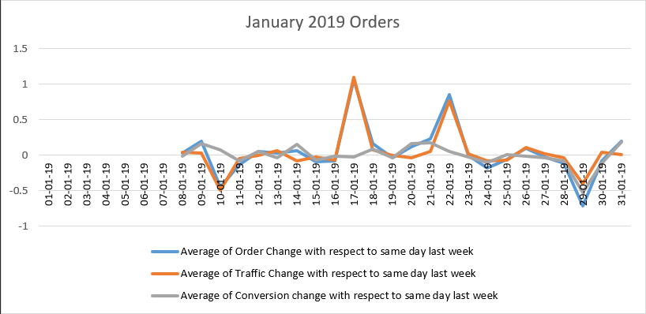

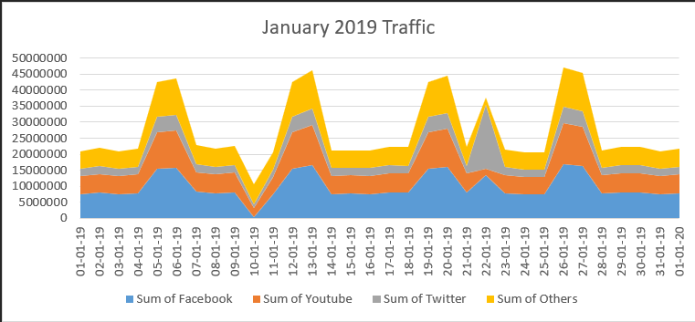

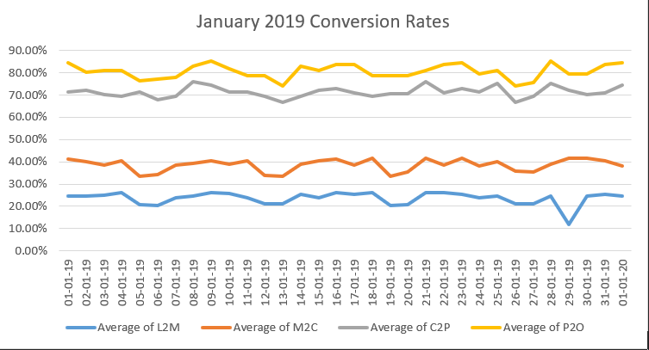

* **Dates with Order Fluctuations w.r.t Same Day Last Week**

1. 10-01-19: 45% Drop
2. 17-01-19: 106% Rise
3. 22-01-19: 85% Rise
4. 29-01-19: 72% Drop

* **Reasons For the Fluctuations**
  1. 10-01-19
* **49% Drop in Traffic w.r.t same day last week: 03-01-2019**
  1. 17-01-19
     + **110% Rise in Traffic w.r.t same day last week: 10-01-2019**
  2. 22-01-19
* **77% Rise in Traffic w.r.t same day last week: 15-01-2019**
  1. 29-01-19
     + **40% Drop in Traffic w.r.t same day last week: 22-01-2019**
     + **Drop in L2M from 26% w.r.t same day last week to 12% because the Count of Restaurants is the 2,74,777 which is lowest in the whole year.**
* **February**

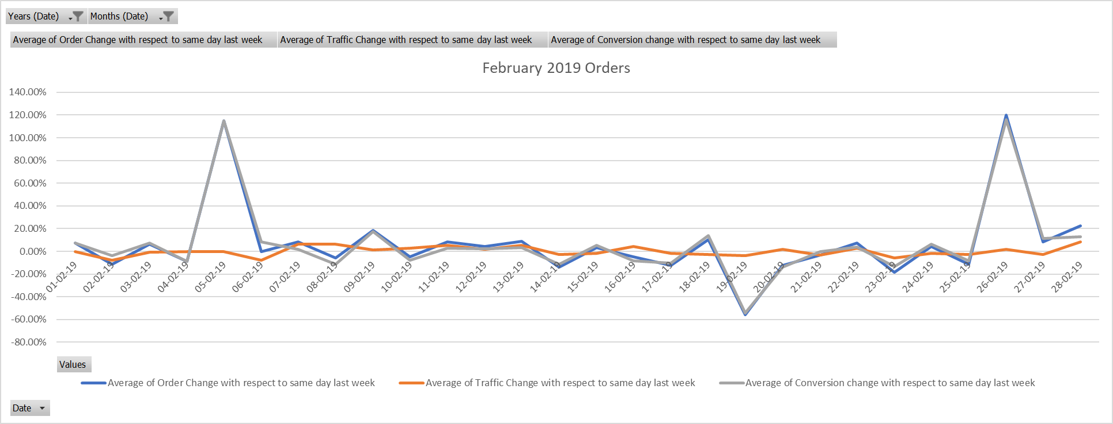

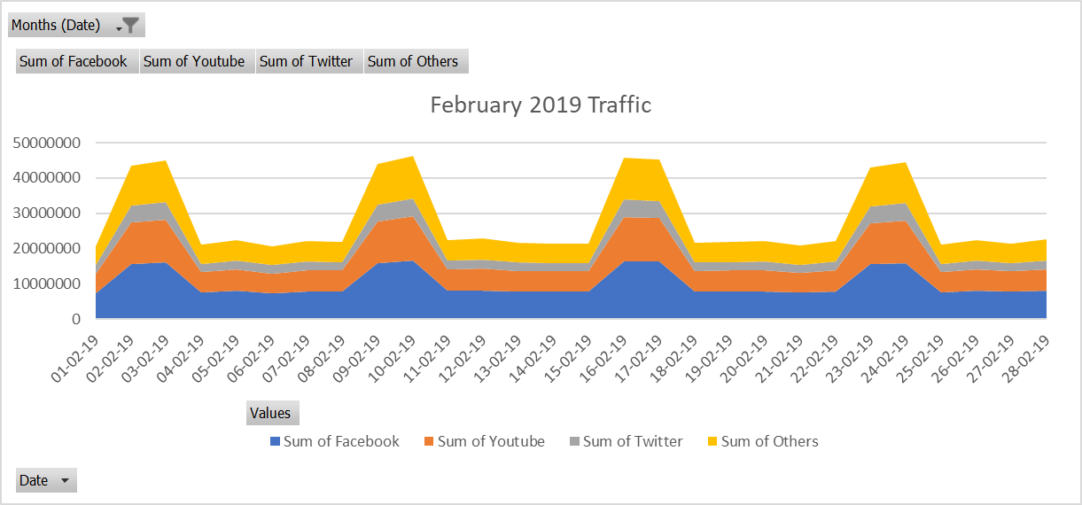

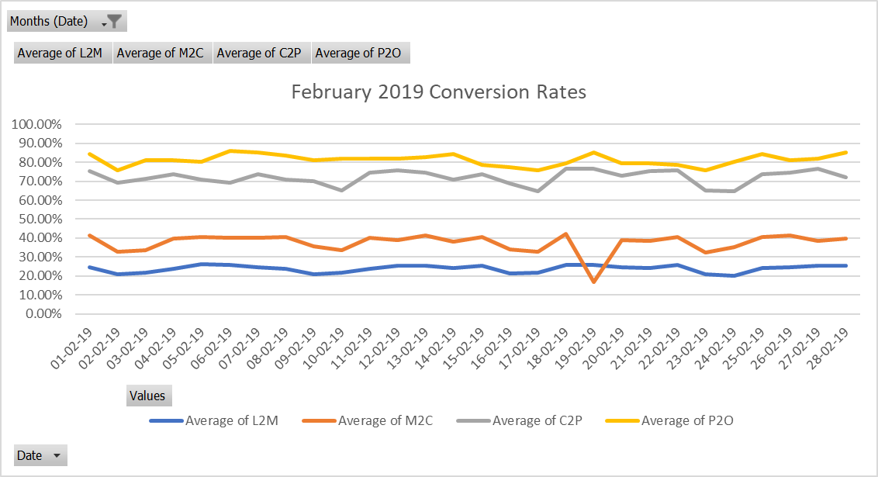

* **Dates with Order Fluctuations w.r.t Same Day Last Week**

1. 05-02-19: 115% Rise
2. 19-02-19: 56% Drop
3. 26-02-19: 120% Rise

* **Reasons For the Fluctuations**
  1. 05-02-19
     + **Rise in L2M from 12% w.r.t same day last week to 26%.**
  2. 19-02-19
     + **Drop in M2C from 39% w.r.t same day last week to 17%.**
  3. 26-02-19
     + **Rise in M2C from 17% w.r.t same day last week to 41%.**
* **March**

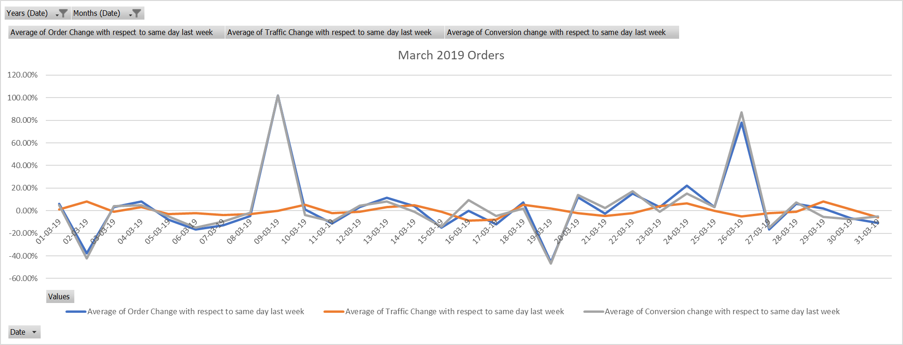

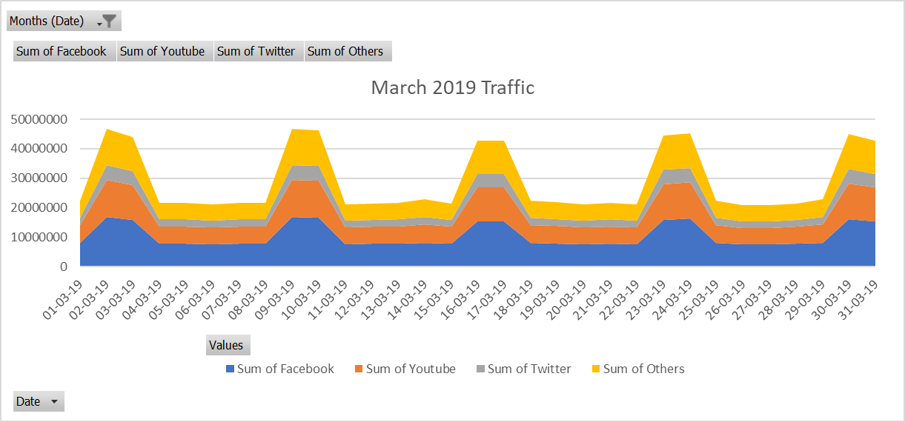

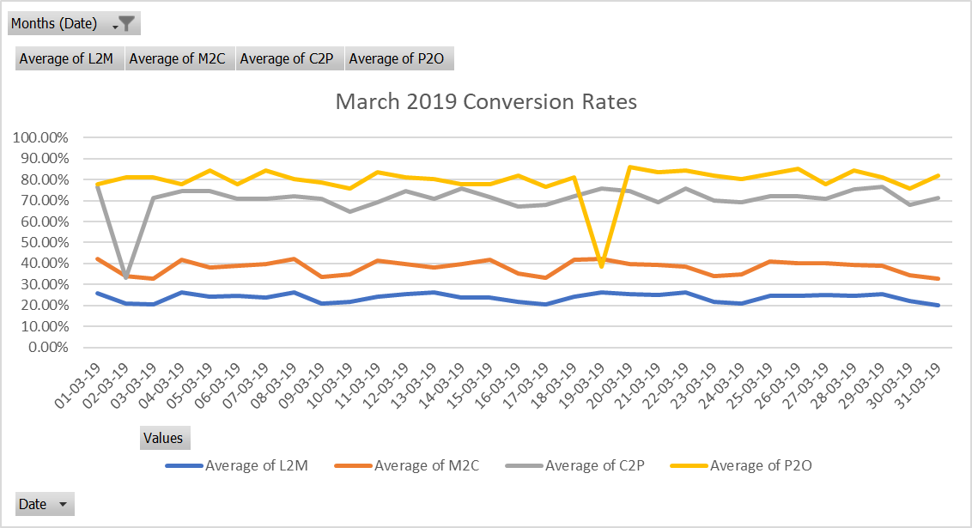

* **Dates with Order Fluctuations w.r.t Same Day Last Week**

1. 02-03-19: 38% Drop
2. 09-03-19: 102% Rise
3. 19-03-19: 46% Drop
4. 26-03-19: 78% Rise

* **Reasons For the Fluctuations**
  1. 02-03-19
     + **Drop in C2P from 65% w.r.t same day last week to 33% because of rise in the Average Delivery Charges per Order to Rs. 56**
  2. 09-03-19
     + **Rise in C2P from 33% w.r.t same day last week to 71%.**
  3. 19-03-19
     + **Drop in P2O from 81% w.r.t same day last week to 39% because Drop Success rate of Payments to 65%.**
  4. 26-03-19
     + **Rise in P2O from 39% w.r.t same day last week to 85%.**
* **April**

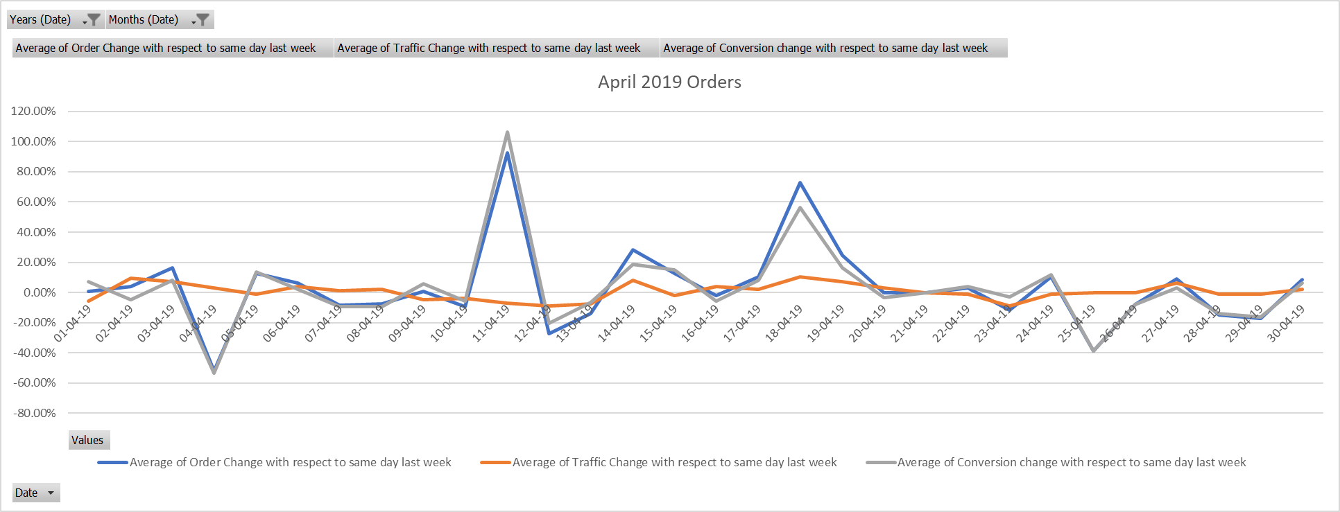

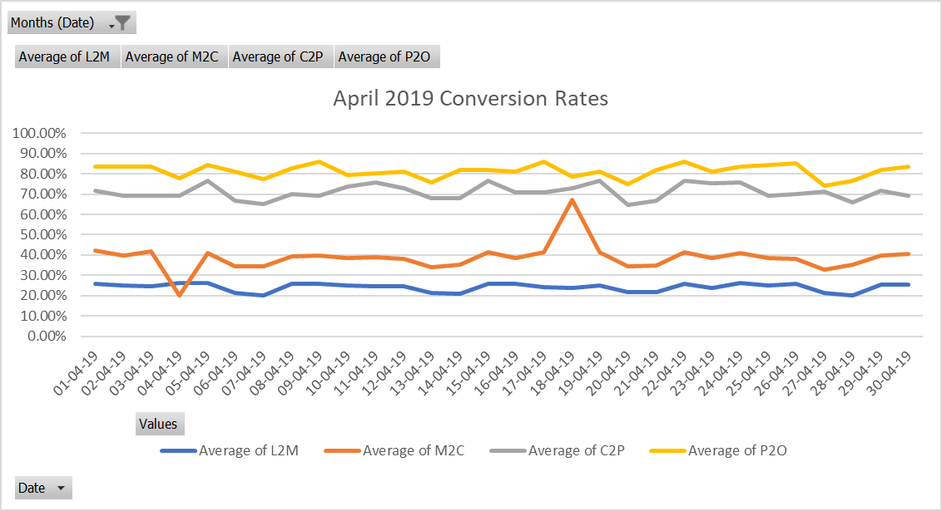

* **Dates with Order Fluctuations w.r.t Same Day Last Week**

1. 04-04-19: 52% Drop
2. 11-04-19: 92% Rise
3. 18-04-19: 73% Rise
4. 25-04-19: 39% Drop

* **Reasons For the Fluctuations**
  1. 04-04-19
     + **Drop in M2C from 39% w.r.t same day last week to 20% because of drop in the Average Discount Percent per Order to 10%**
  2. 11-04-19
     + **Rise in M2C from 20% w.r.t same day last week to 39%.**
  3. 18-04-19
     + **Rise in M2C from 39% w.r.t same day last week to 67% because Rise in Average Discount Percent per Order to 29%**
  4. 25-04-19
     + **Drop in M2C from 67% w.r.t same day last week to 38%.**
* **June**

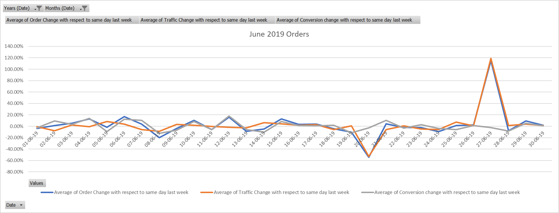

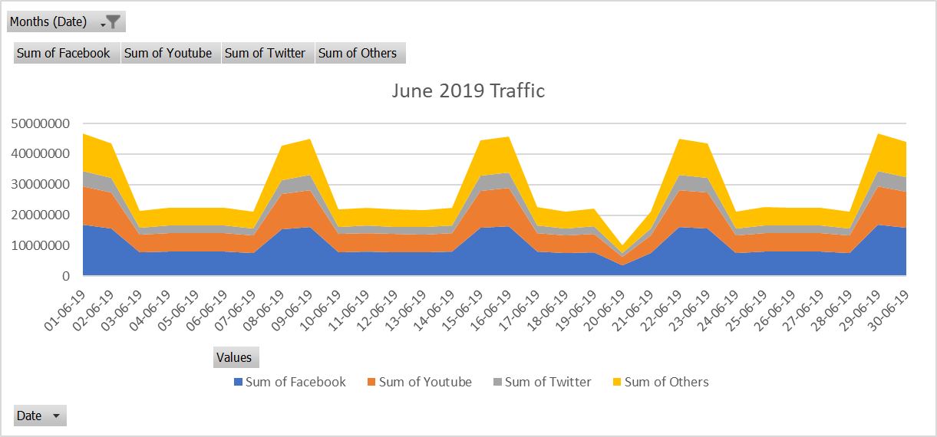

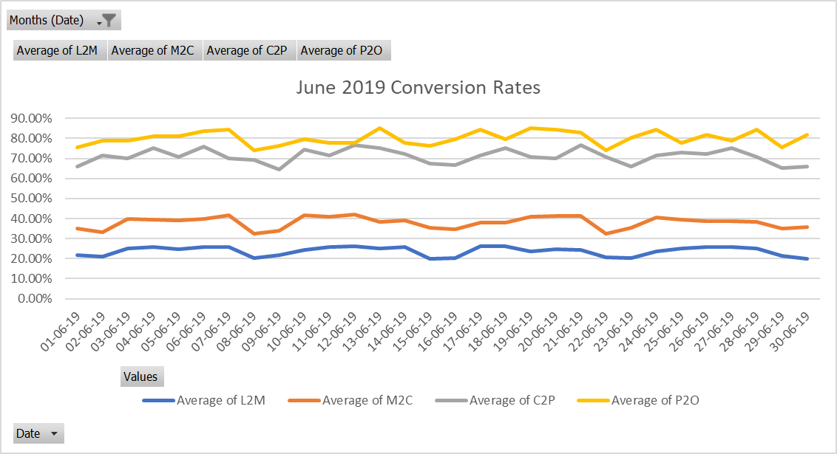

* **Dates with Order Fluctuations w.r.t Same Day Last Week**

1. 20-06-19: 54% Drop
2. 27-06-19: 115% Rise

* **Reasons For the Fluctuations**
  1. 20-06-19
     + **53% Drop in Traffic w.r.t same day last week: 13-06-2019**
  2. 27-06-19
     + **119% Rise in Traffic w.r.t same day last week: 20-06-2019**
* **July**

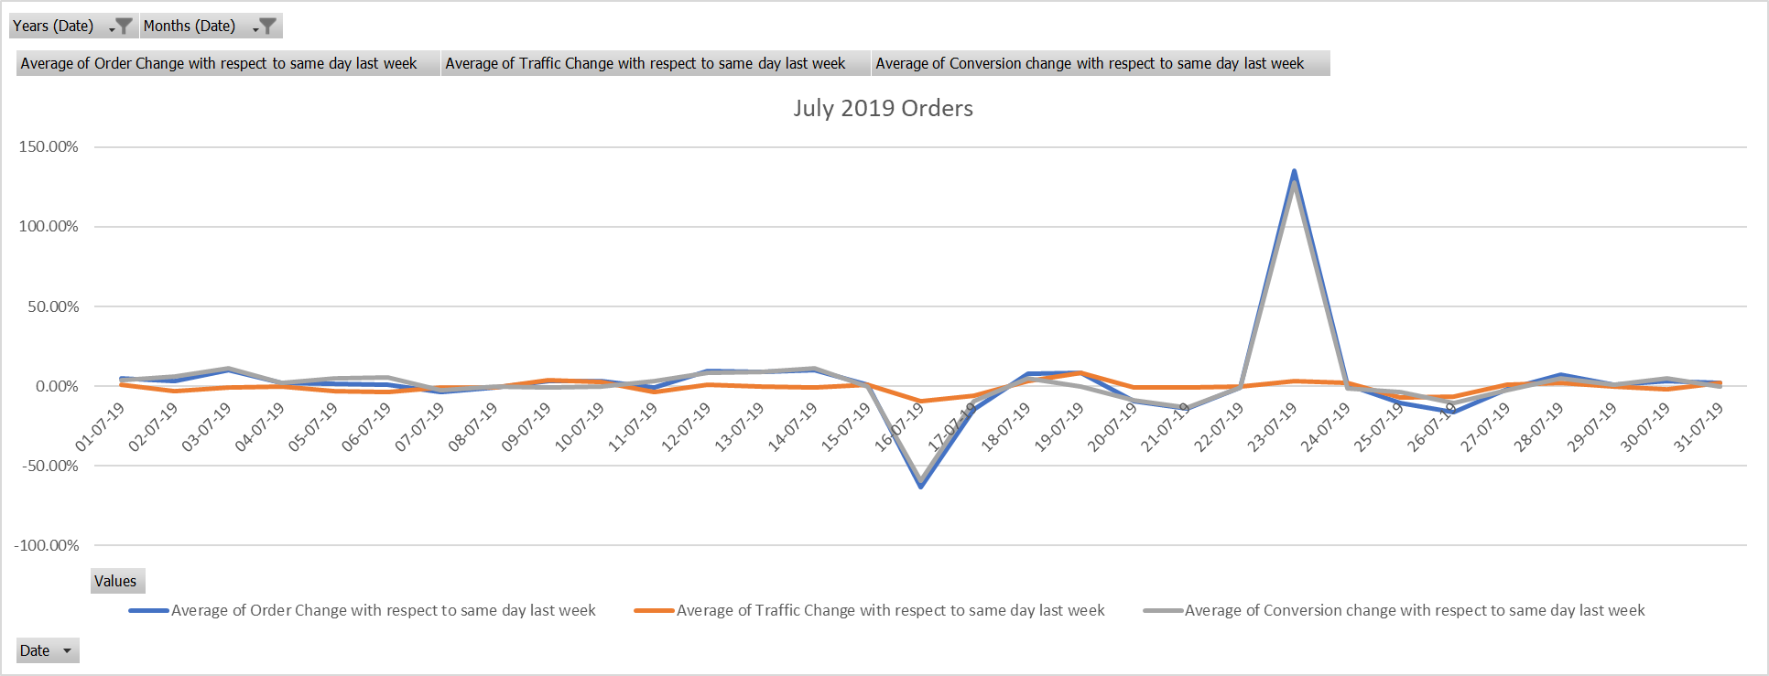

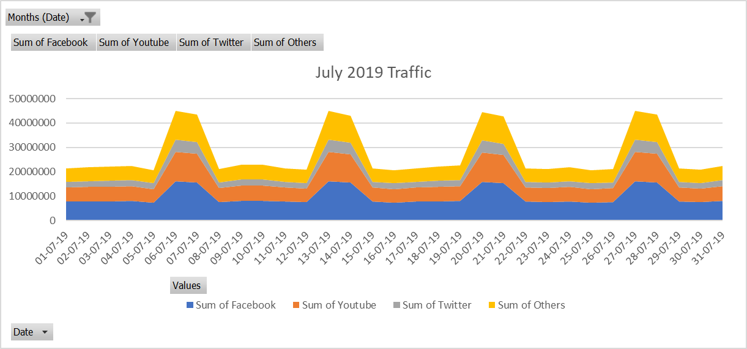

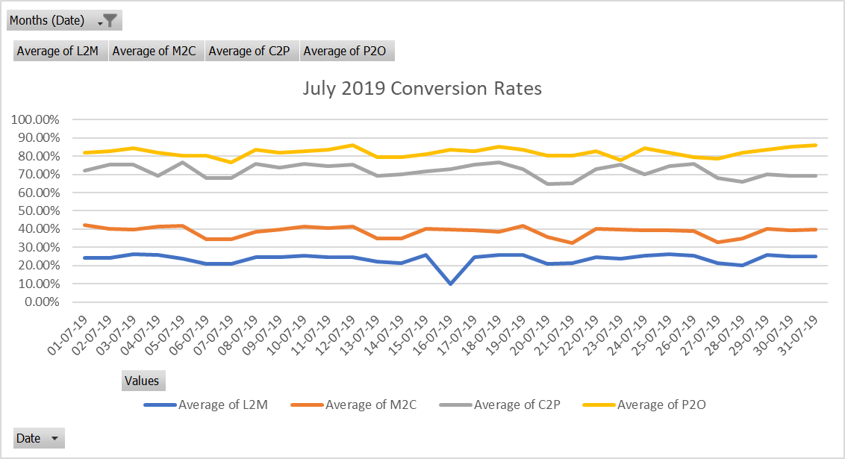

* **Dates with Order Fluctuations w.r.t Same Day Last Week**

1. 16-07-19: 63% Drop
2. 23-07-19: 135% Rise

* **Reasons For the Fluctuations**
  1. 16-07-19
     + **Drop in L2M from 25% w.r.t same day last week to 10% because of rise in Average Cost for Two to 458.**
  2. 23-07-19
     + **Rise in L2M from 10% w.r.t same day last week to 24%.**
* **August**

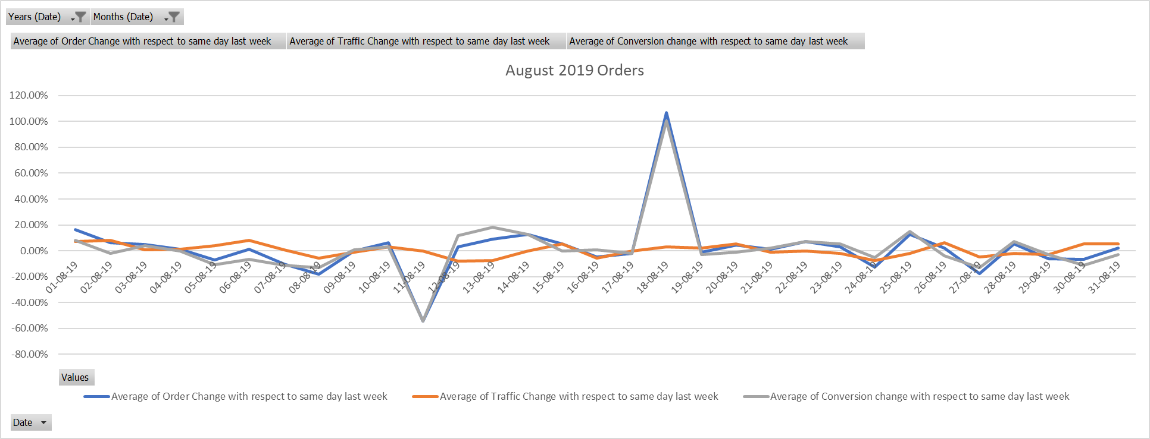

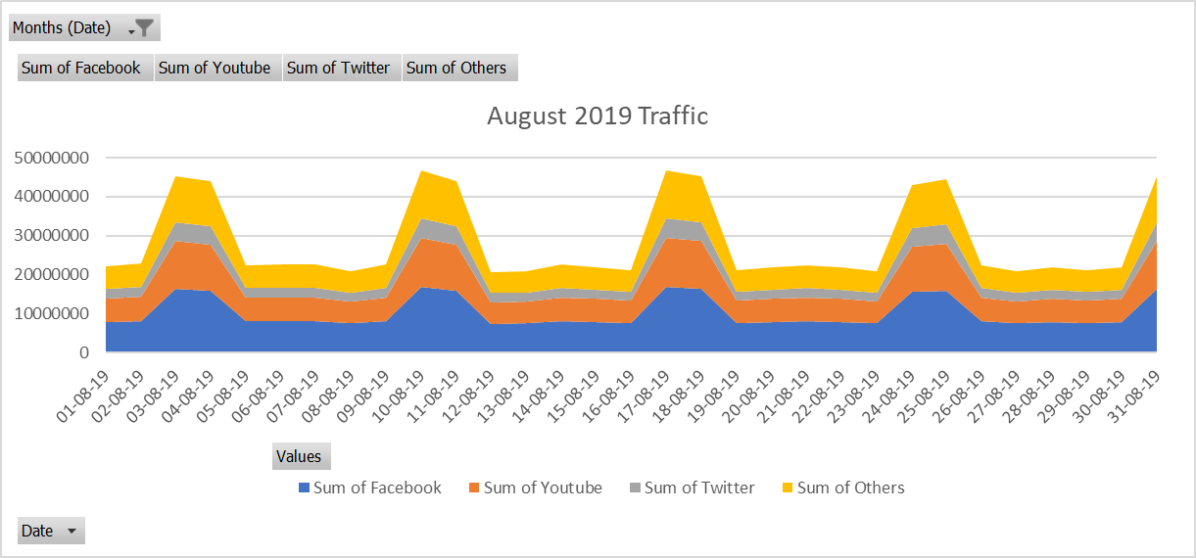

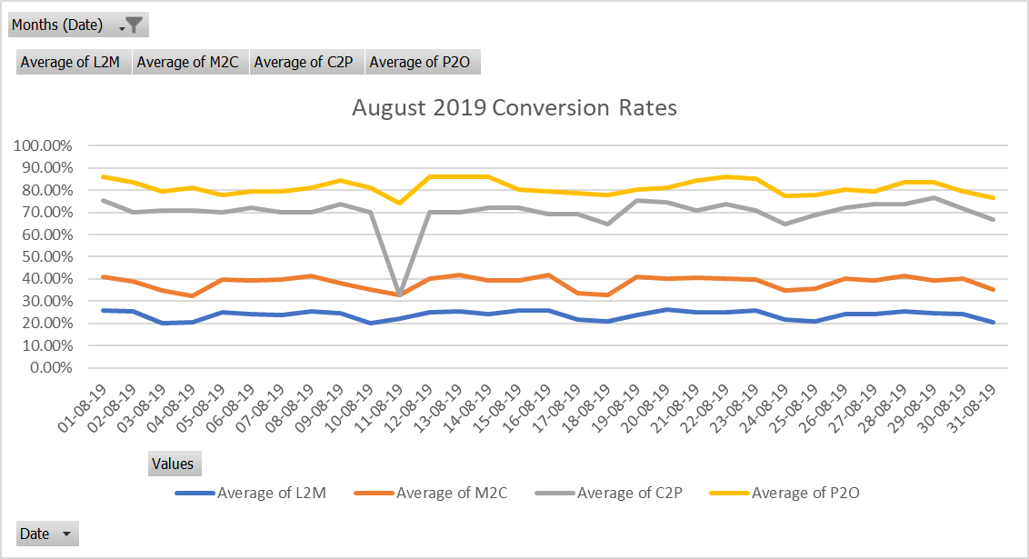

* **Dates with Order Fluctuations w.r.t Same Day Last Week**

1. 11-08-19: 54% Drop
2. 18-08-19: 107% Rise

* **Reasons For the Fluctuations**
  1. 11-08-19
     + **Drop in C2P from 71% w.r.t same day last week to 33% because of rise in Average Packaging Charges to 29.**
  2. 18-08-19
     + **Rise in C2P from 33% w.r.t same day last week to 65%.**
* **September**

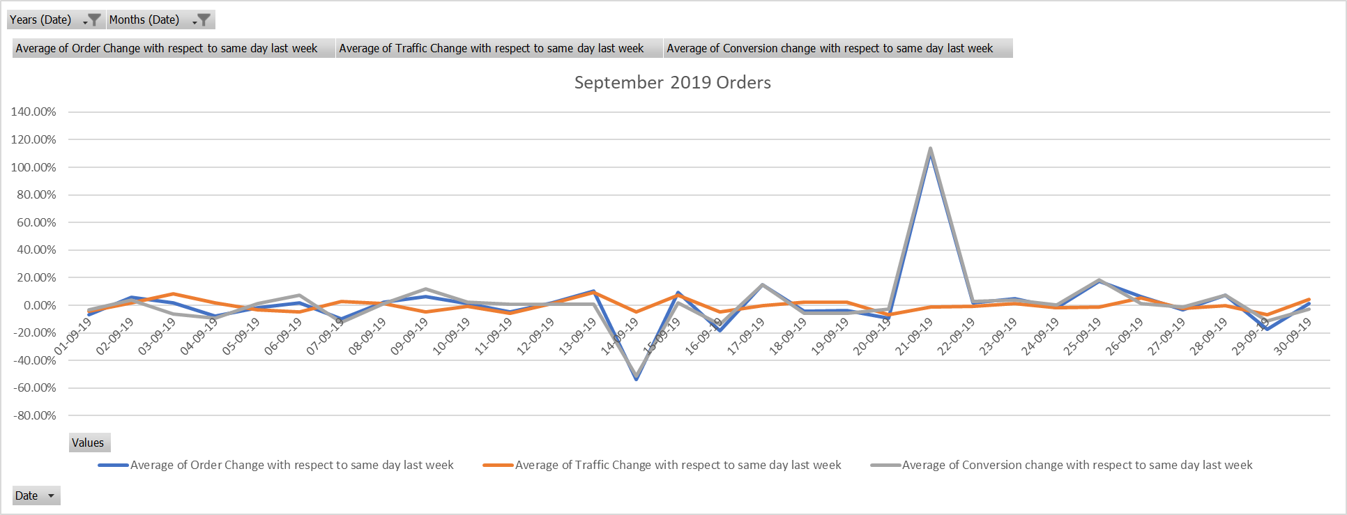

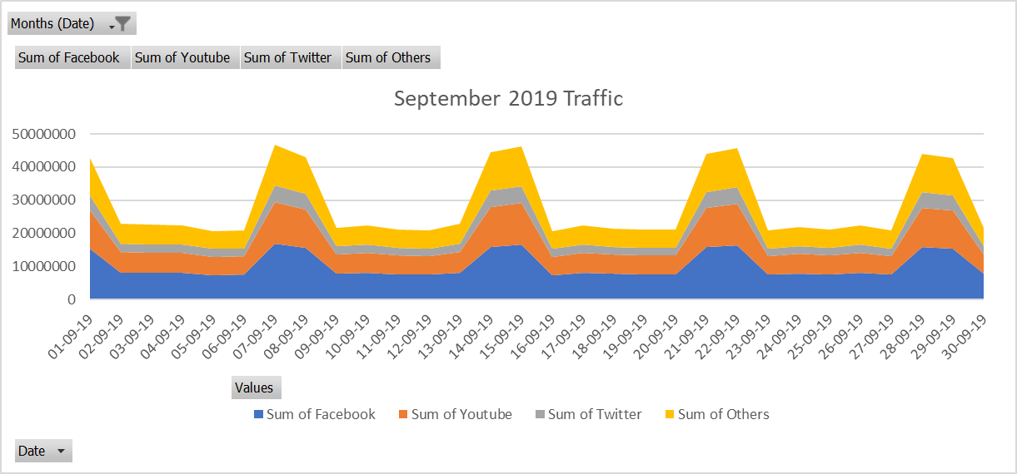

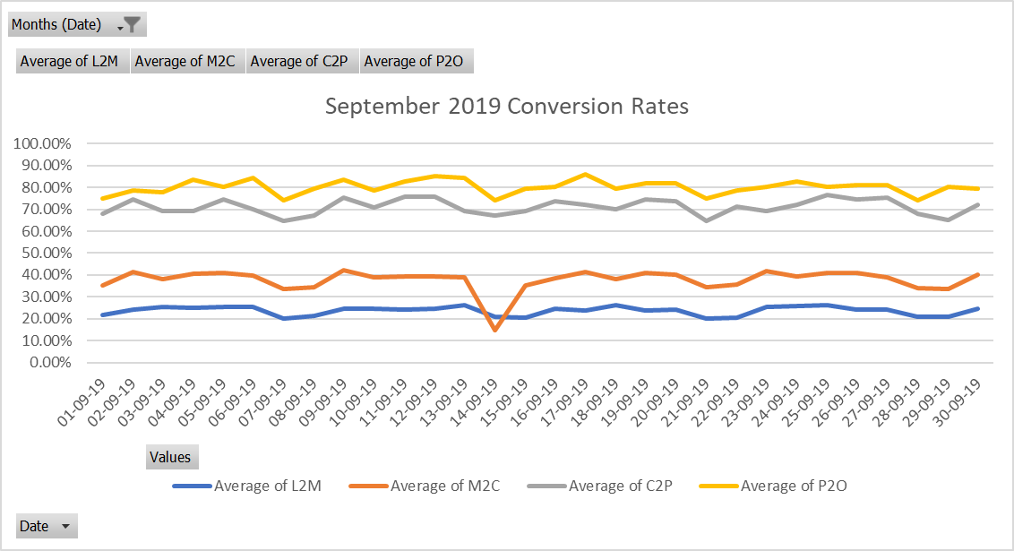

* **Dates with Order Fluctuations w.r.t Same Day Last Week**

1. 14-09-19: 54% Drop
2. 21-09-19: 112% Rise

* **Reasons For the Fluctuations**
  1. 14-09-19
     + **Drop in M2C from 34% w.r.t same day last week to 15% because of rise in Out-of-Stock items per Restaurant to 64.**
  2. 21-09-19
     + **Rise in M2C from 15% w.r.t same day last week to 34%.**
* **November**

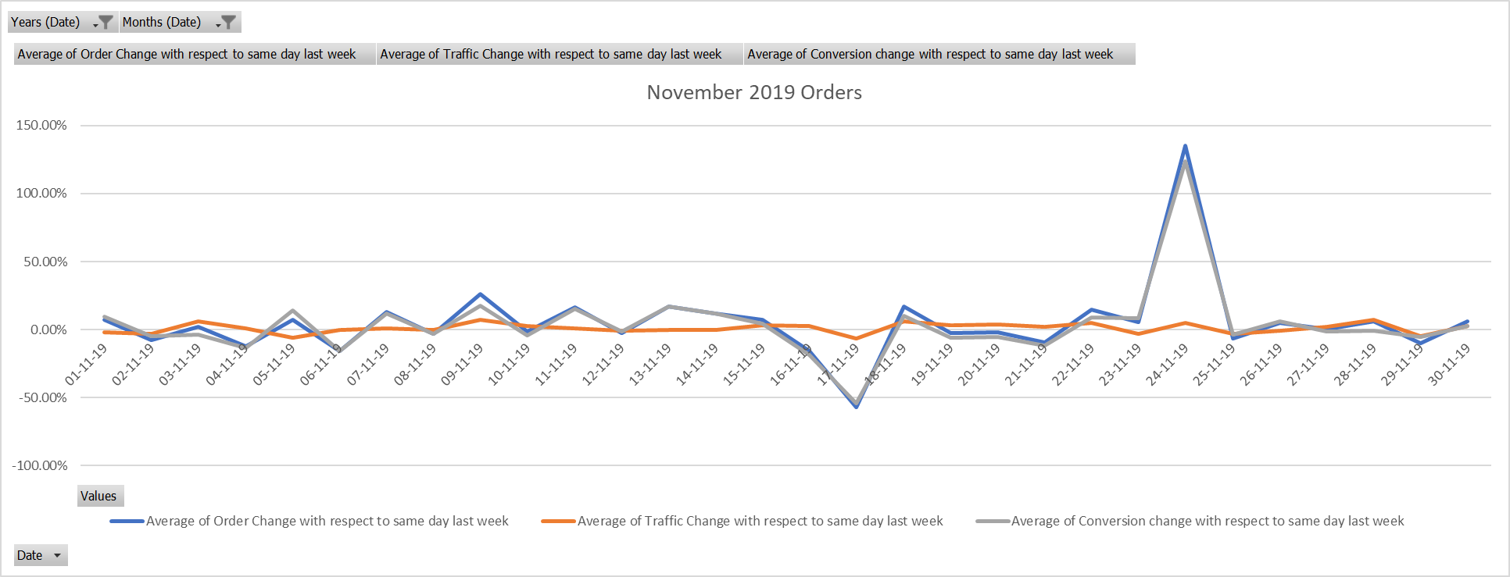

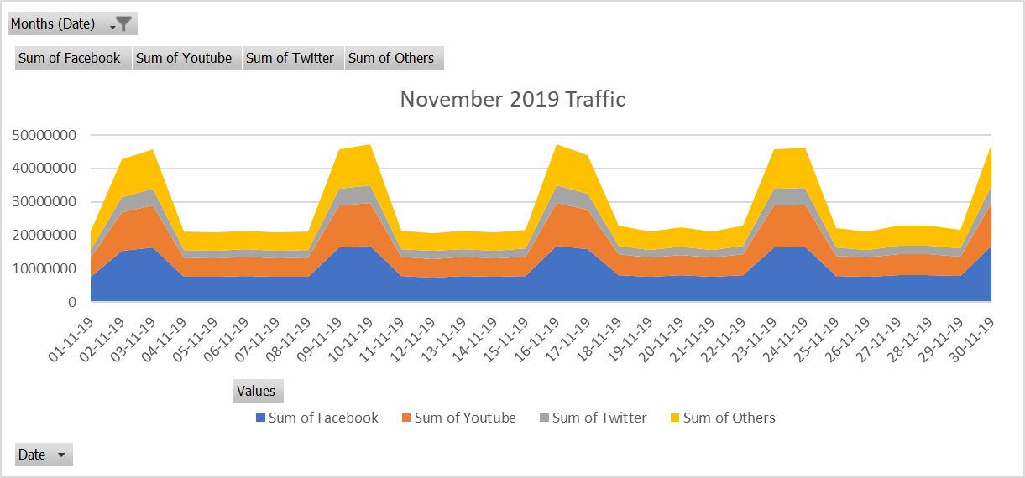

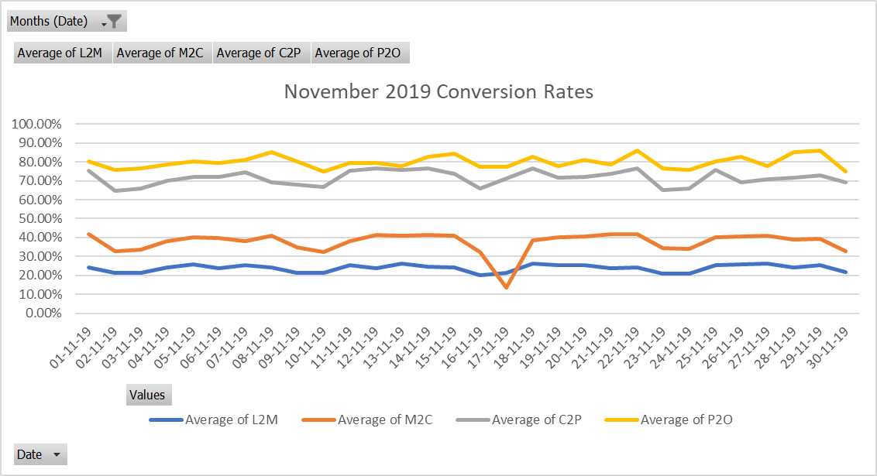

* **Dates with Order Fluctuations w.r.t Same Day Last Week**

1. 17-11-19: 57% Drop
2. 24-11-19: 135% Rise

* **Reasons For the Fluctuations**
  1. 17-11-19
     + **Drop in M2C from 32% w.r.t same day last week to 14% because of rise in Out-of-Stock items per Restaurant to 112.**
  2. 24-11-19
     + **Rise in M2C from 14% w.r.t same day last week to 34%.**

**3. Conclusion.**

In conclusion, this Funnel Analysis Report sheds light on the dynamic nature of order trends, traffic, and conversions on the Swiggy platform. By understanding the factors contributing to fluctuations and by implementing the suggested recommendations, Swiggy can further optimize its operations and continue to provide exceptional service to its customers. The report provides a roadmap for informed decision-making and strategic actions to achieve these objectives.

**4. Recommendations.**

To address order drops attributed to channel-wise traffic issues, consider optimizing traffic sources and promotional strategies.

For issues related to restaurant listings, focus on improving restaurant quality and selection.

To enhance conversion rates (M2C and C2P), optimize the user experience, pricing, and checkout process.

Monitor and improve payment success rates and out-of-stock item issues to boost P2O and M2C conversions.